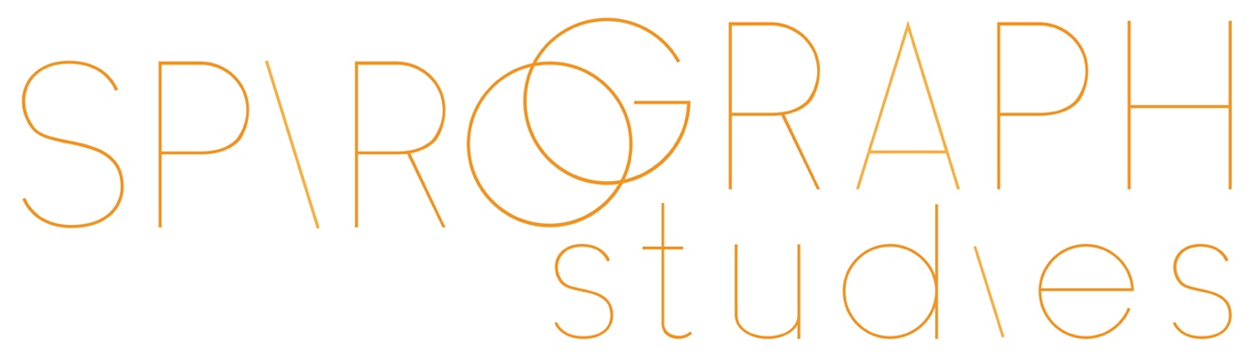

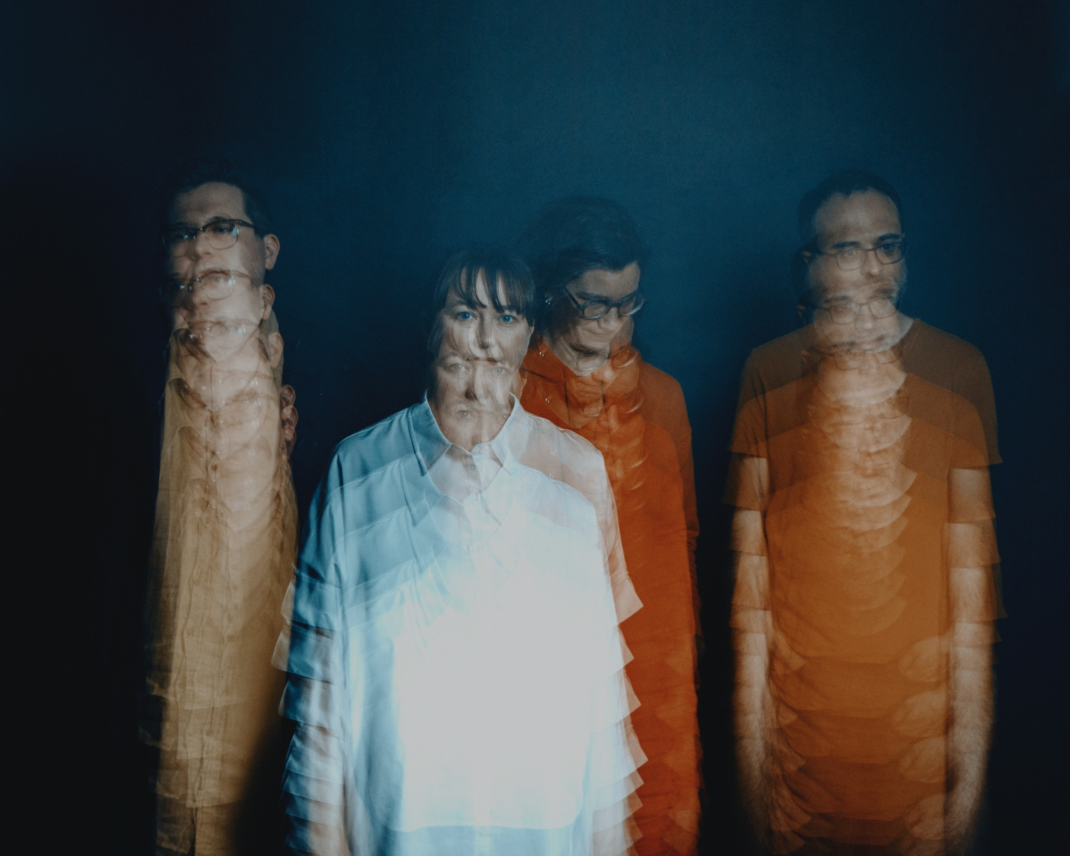

(photo credit: Wilk)

Cinematic and dream-like, Spirograph Studies sculpt live soundtracks, creating different moods and soundscapes. They shamelessly use influences from post-rock and minimalism to create their post-jazz, genre-bending sound. They introduce themes which slowly build to fill out the space they perform in, drawing on different sonic influences from each track.

Spirograph Studies have been carving out a niche in the Australian music landscape with their unique approach, led by bassist and composer Tamara Murphy. They currently have two releases commercially available: Kindness, Not Courtesy (2019) and Lowlights (2021) available through their Bandcamp page.

Their albums have been shortlisted for Music Victoria awards, featured on The Best Jazz on Bandcamp list (October 2021), Album of the Week on ABC Jazz and the single Anteloper was one of the Top Tracks on Feature Sounds (PBS Radio). They toured Australia and New Zealand to promote their first album release in 2019, receiving glowing reviews.

Spirograph Studies:
Fran Swinn – guitar
James McLean – drums
Luke Howard – piano
Tamara Murphy – bass

Press:

“If there is one quality which most permeates the music of Spirograph Studies, it is melodic beauty.”

– Eric Myers, The Weekend Australian, July 3, 2022

“There’s a lot of subtlety at work on this enjoyable set from the Melbourne-based quartet Spirograph Studies, and the payoff to that approach are some pretty epic moments. It’s just as engaging to trace the path of the small, logical steps that lead up the huge melodic statements as it is to arrive at their destination. Those slow builds are the album’s winning quality, and border on addictive.”

– Dave Sumner, Best Jazz on Bandcamp List, October 2021

“This album absorbed me with its understated movement, subtle colour shifts, beautiful melodic interaction, and textural approach to music making.”

– Rafael Karlen, The Music Trust, July 27, 2020

“…gorgeous soundscapes…”
“It is not often listeners are invited into something so intricate yet still so accessible.”

– Hayden Pyke, WritingInCapitalLetters, 2019

“'Spirograph Studies' is a wonder - a muted sprawl of acoustic and electric instrumentation, a deep and evocative listen.”

– Sydney Women’s International Jazz Festival, 2019

“…original and fascinating music…”

– Rob Kennedy, Canberra City News, August 17, 2019

“…startling originality…”
“…ruminative and minimalist…”

– Eric Myers, The Weekend Australian, August 24, 2019

